|  |  |
| --- | --- |
| Course Name | ITD 2313 – Script Programming |
| Instructor | Mr. Pranger |
| Student Name | Trey Mobley |
| Due date | 06/09/2021 |
| Grade | <grade earned here> |
| Grading Comments | <instructor comments here> |

Pg. 103

1.

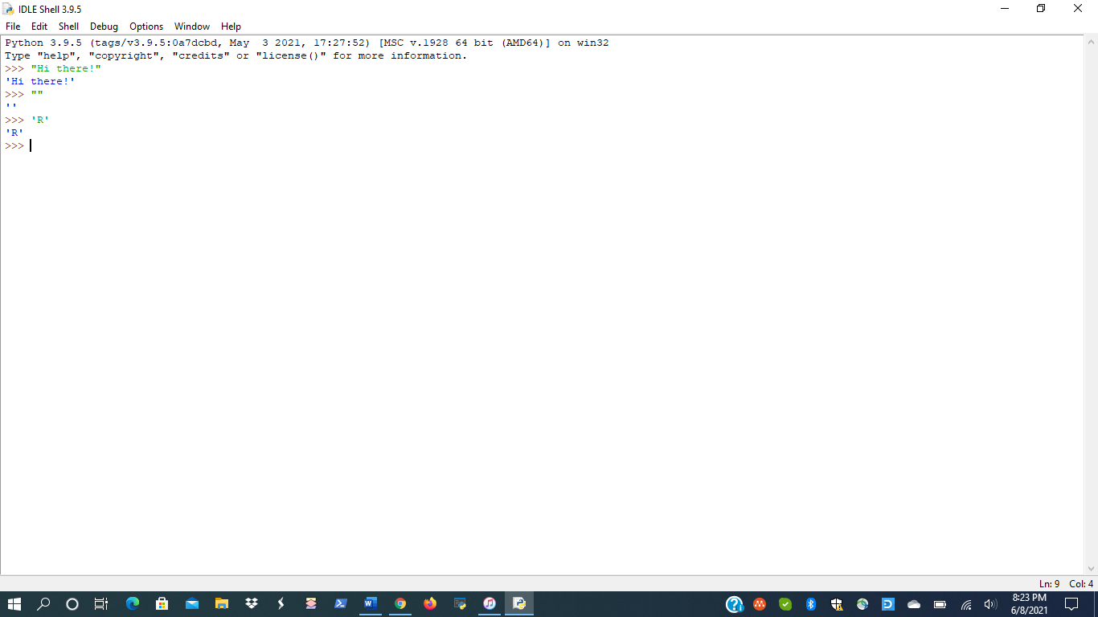

2.

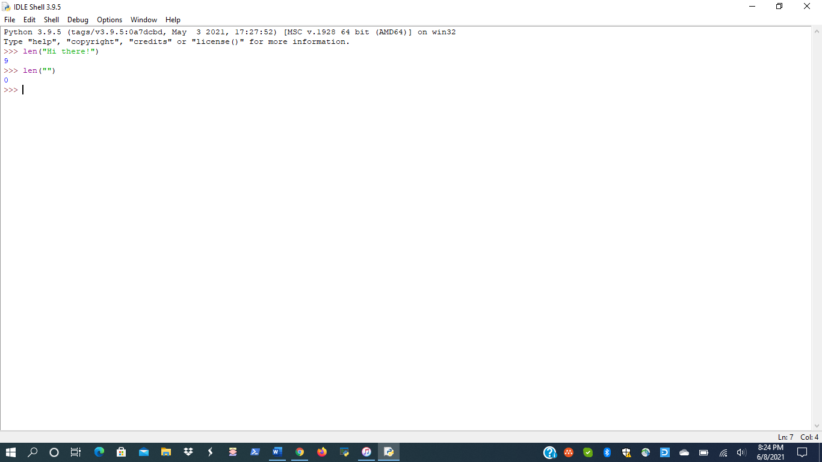

Pg. 104

1.

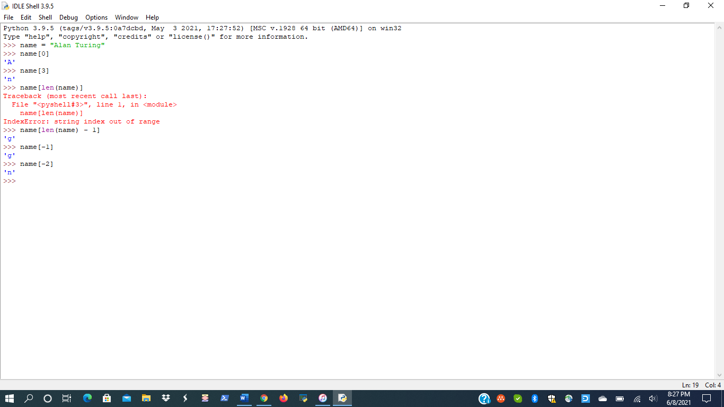

2.

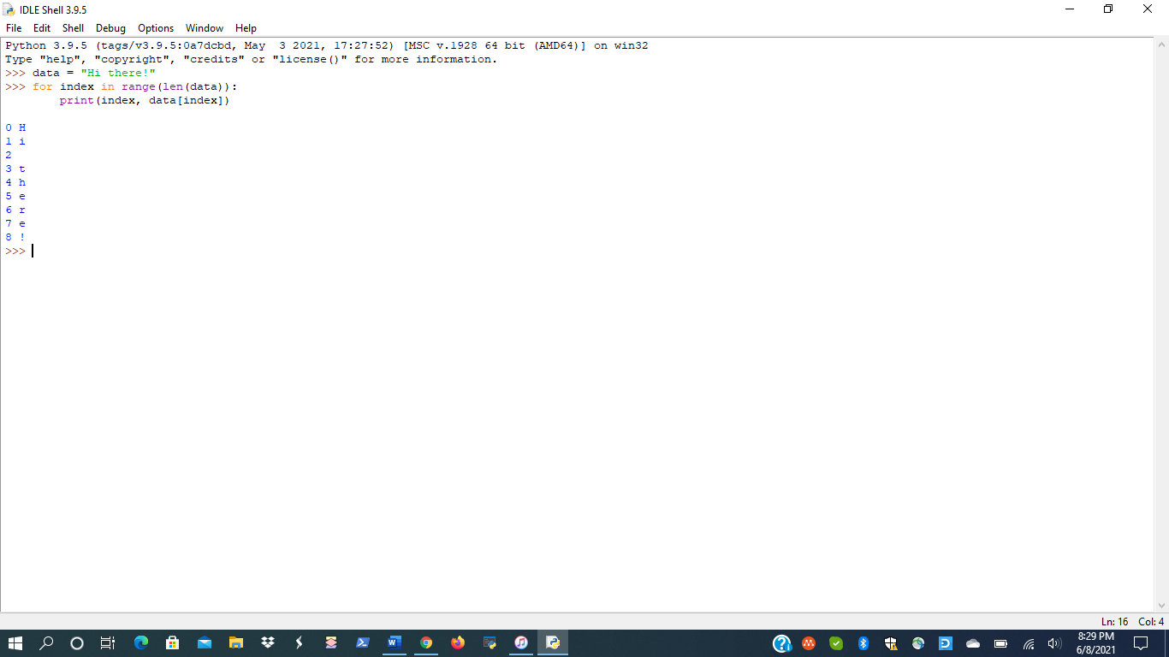

Pg. 105

1.

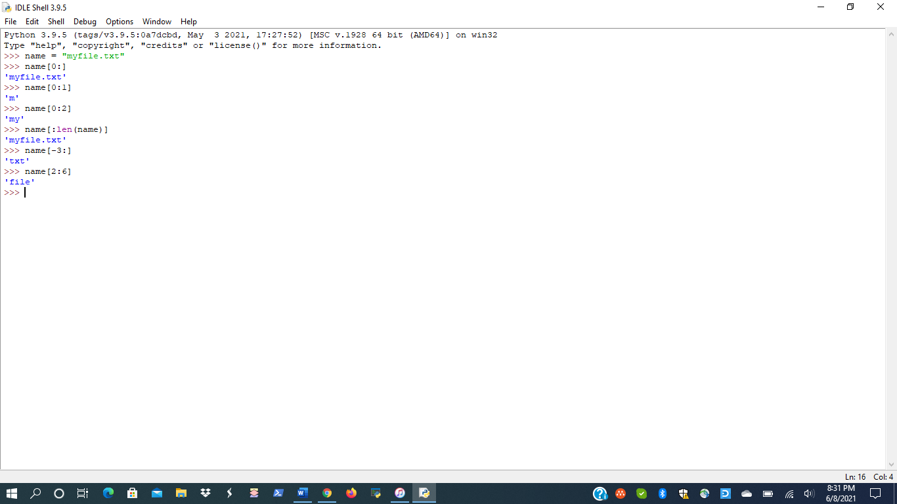

Pg. 106

1.

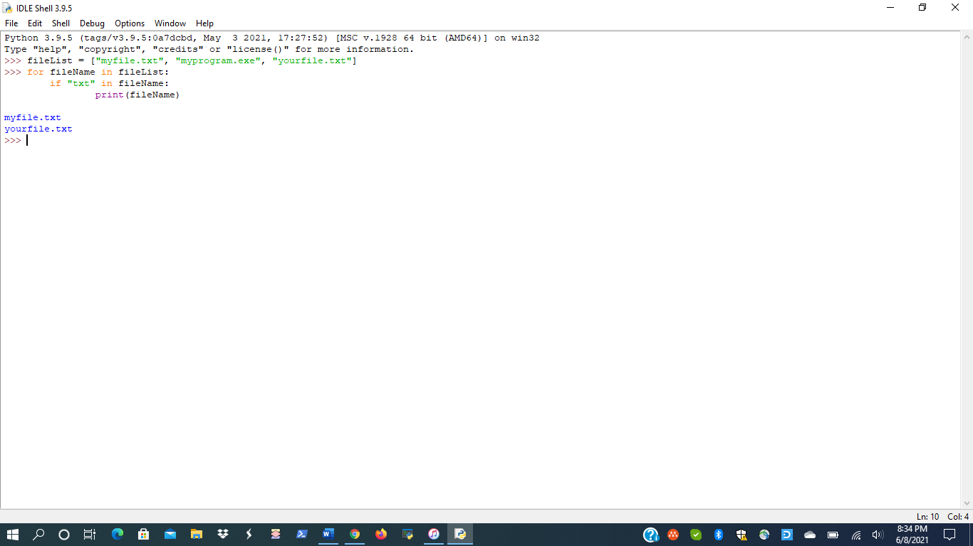

Pg. 108

1.

Pg. 111

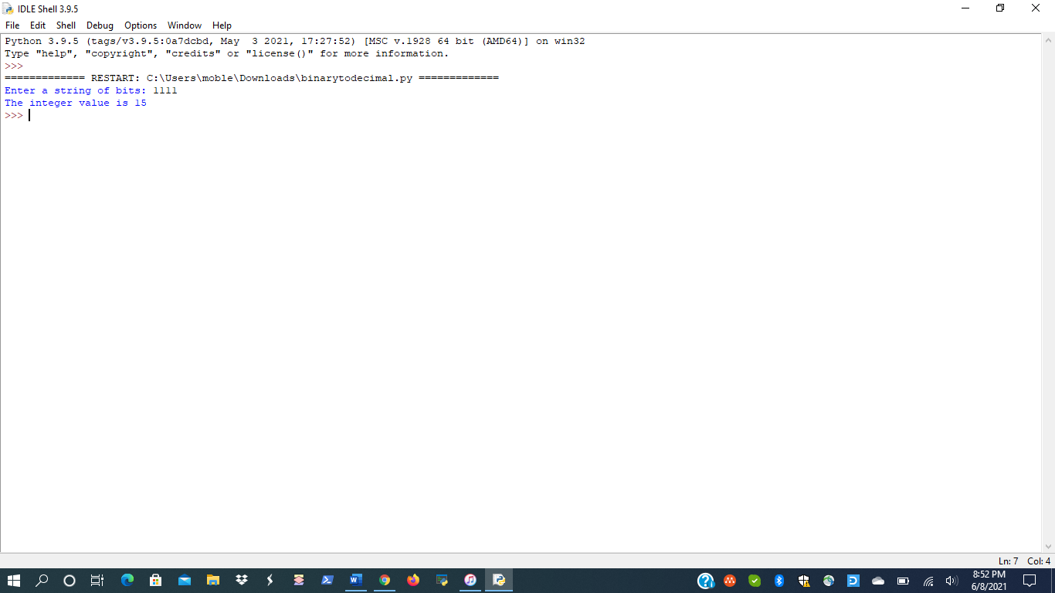

Pg. 112

1.

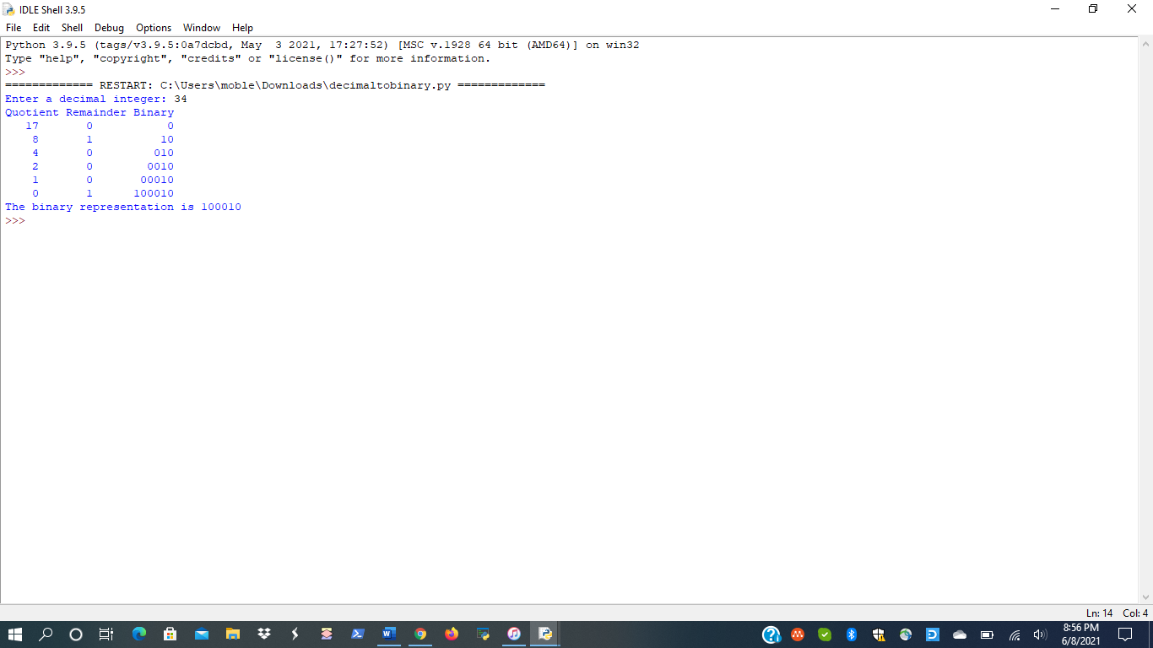

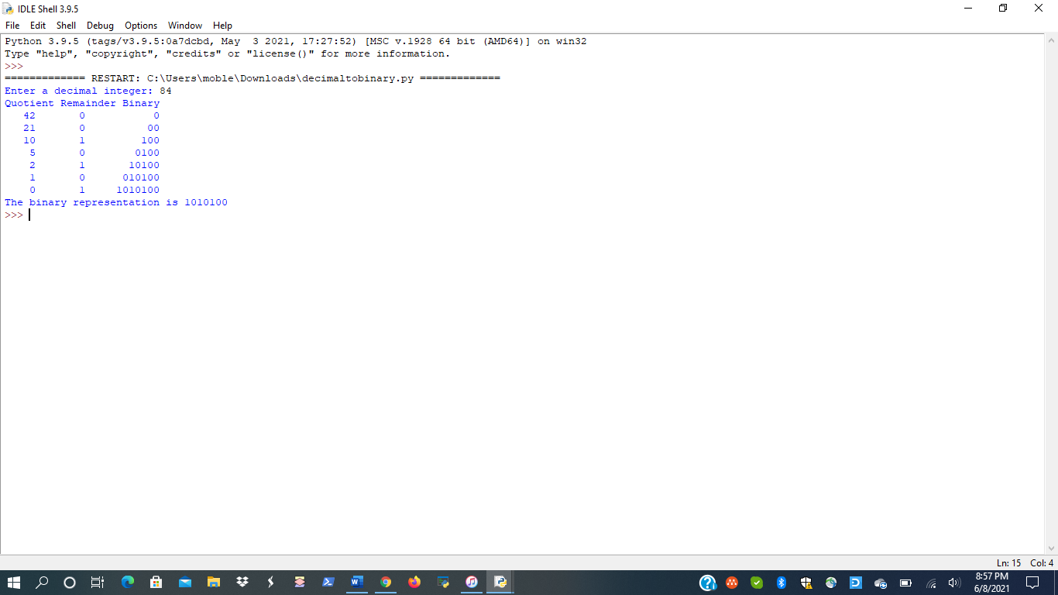

Pg. 115

1.

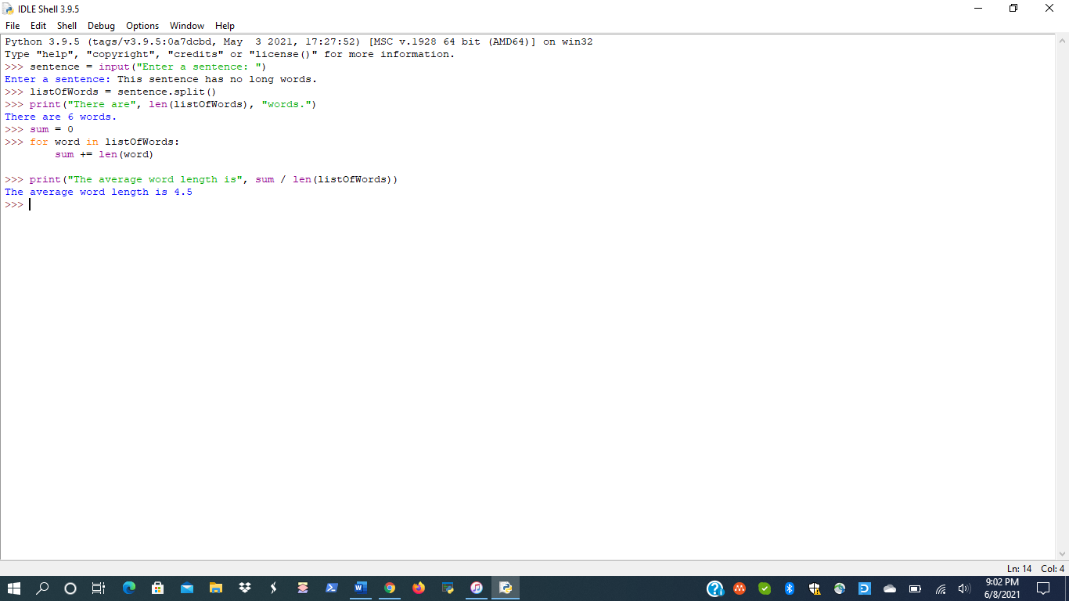

Pg. 117

1.

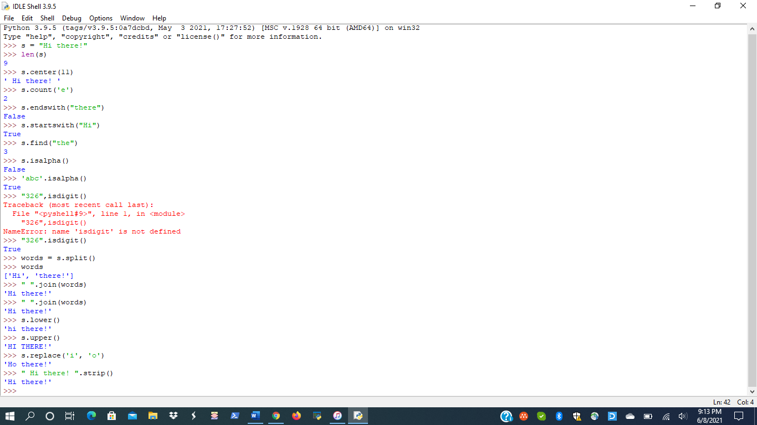

2.

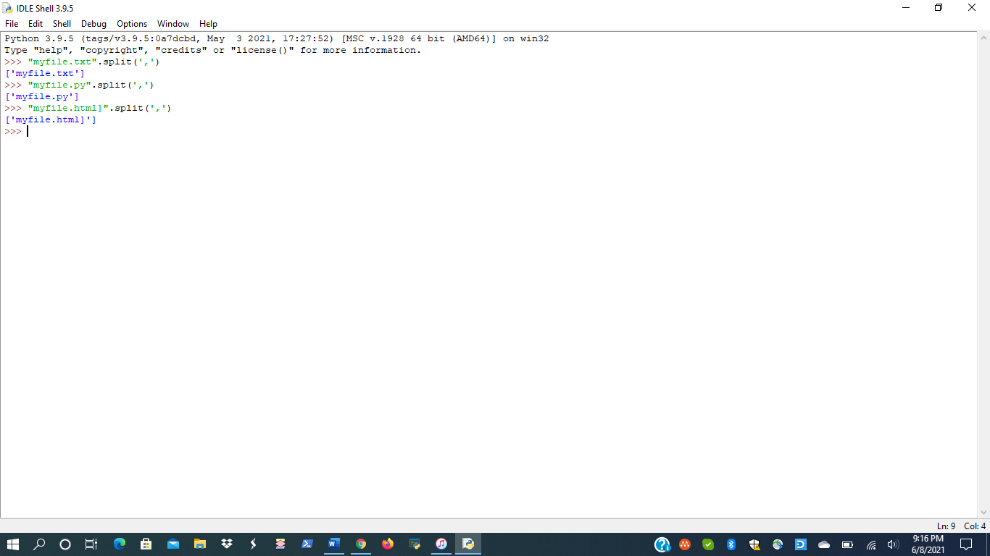

Pg. 119

1., 2.

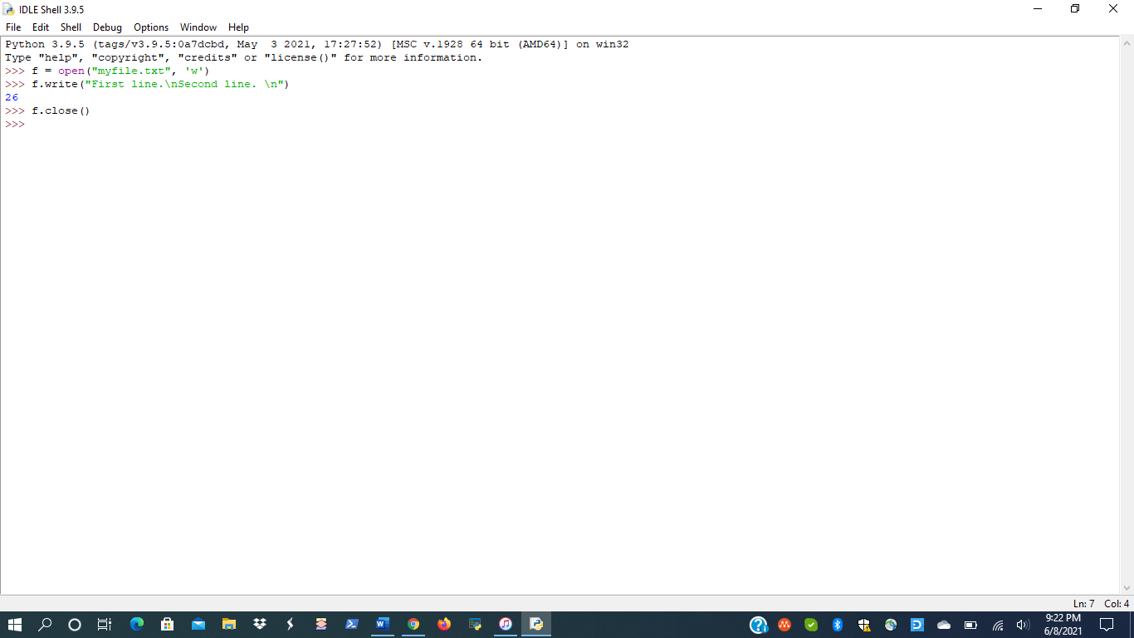

Pg. 120

1.

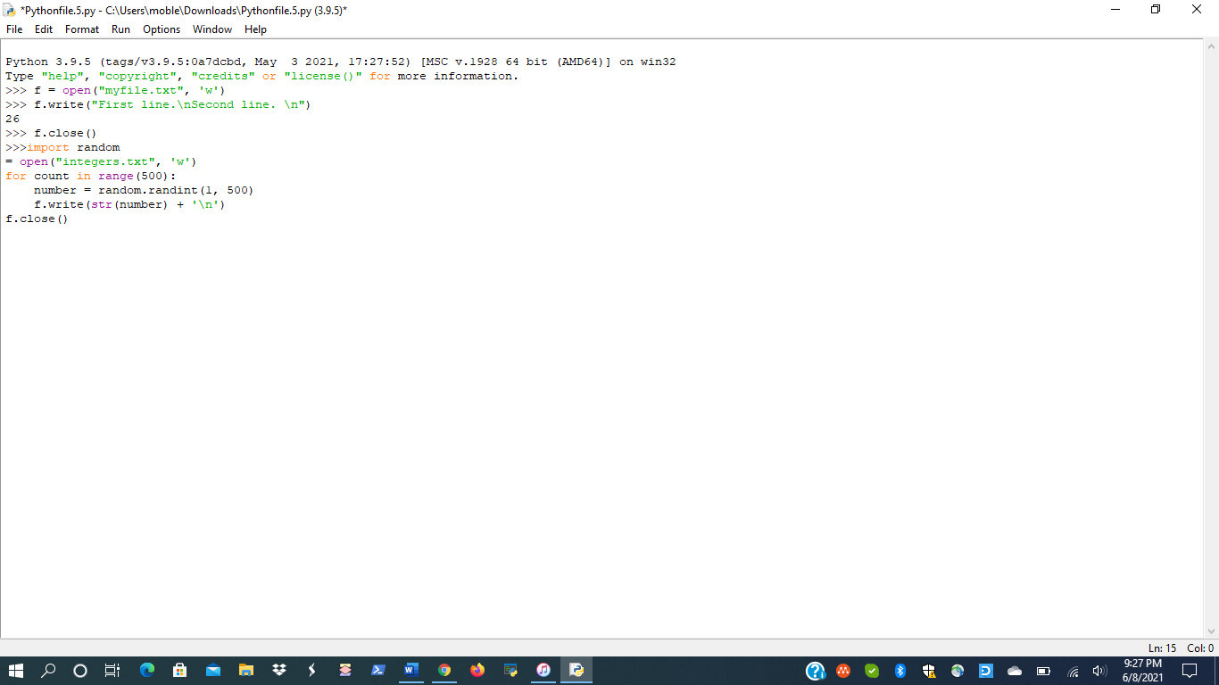

2.

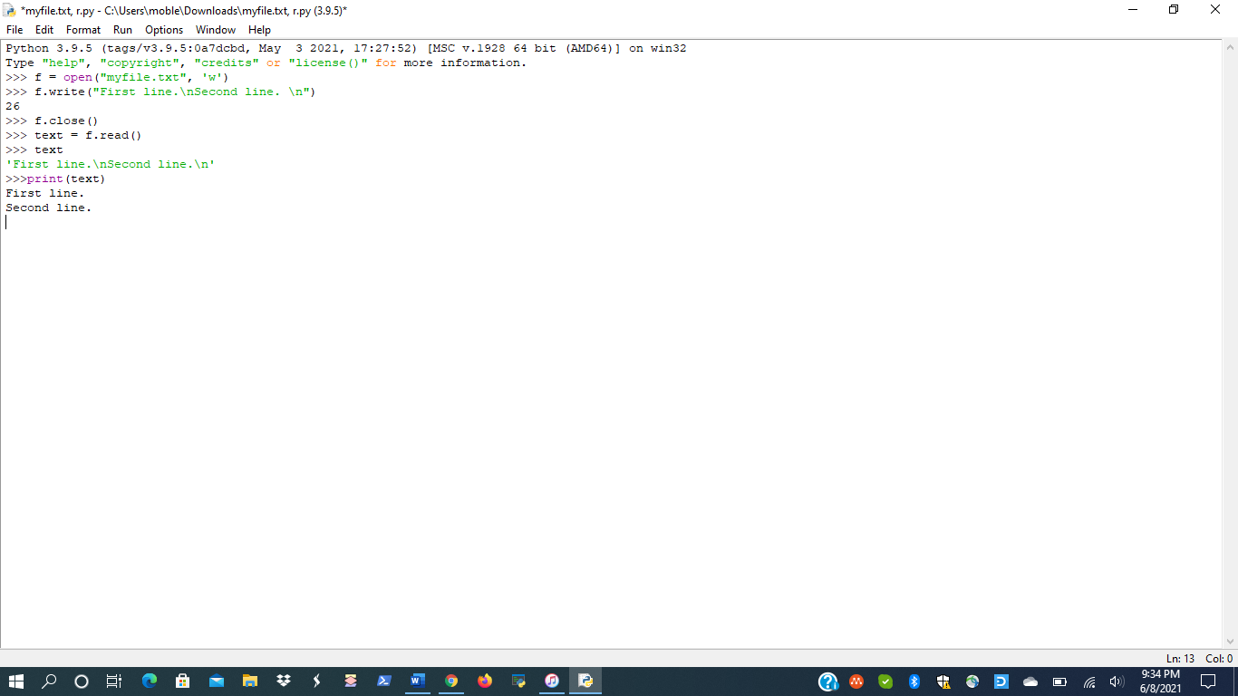

3.

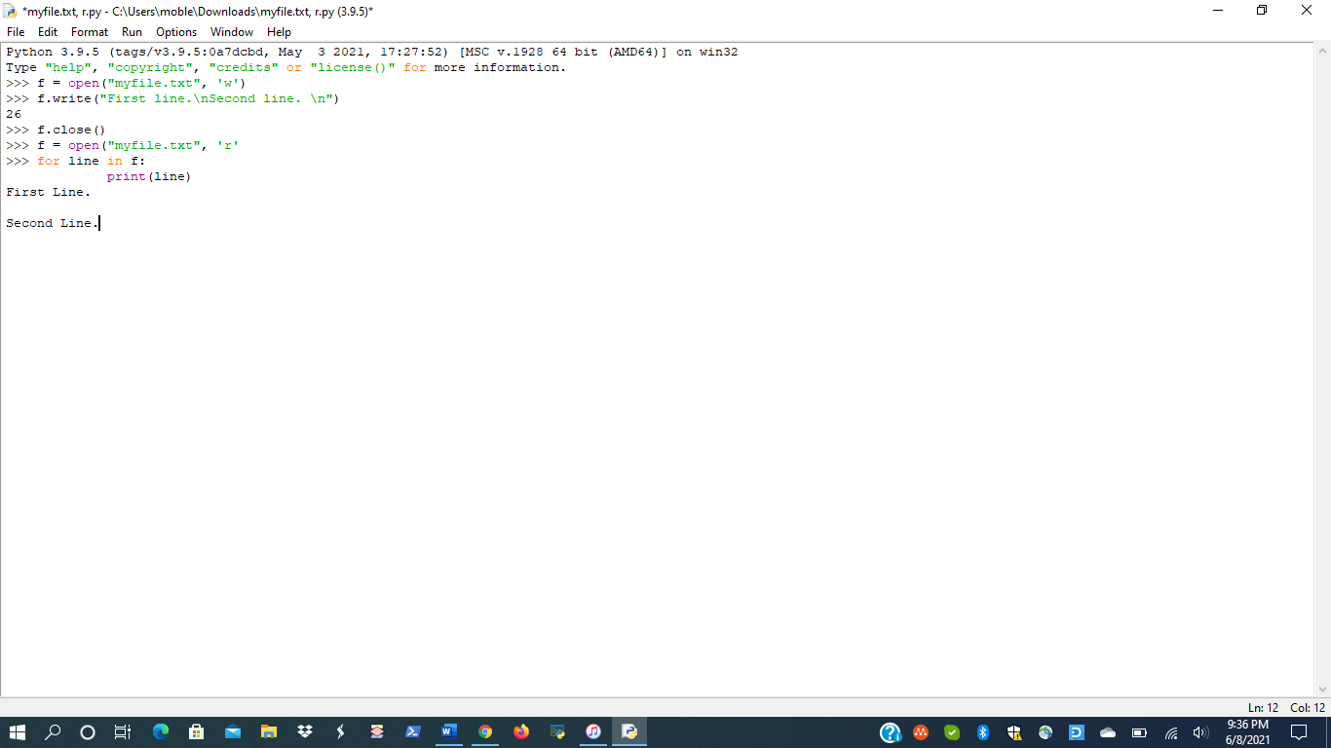

Pg. 121

1.

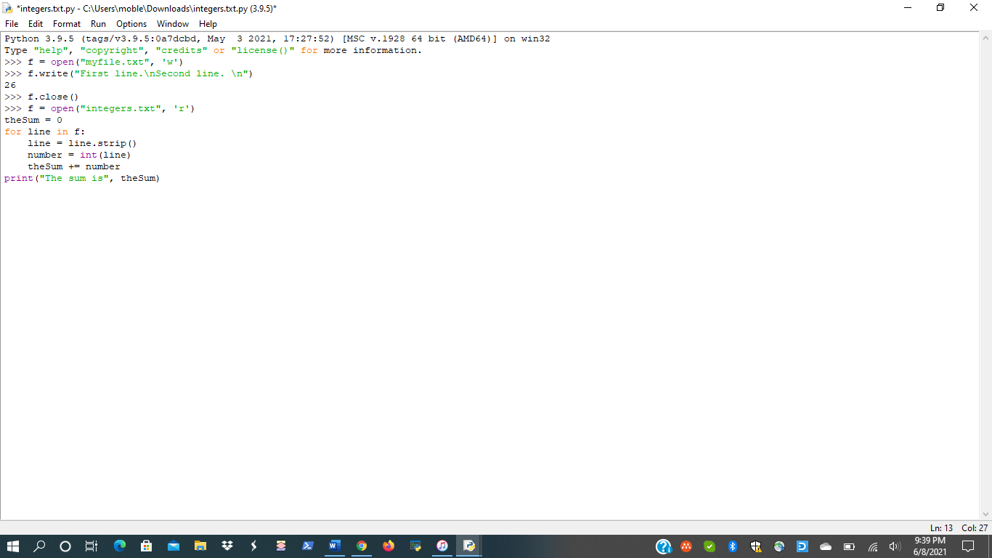

Pg. 122

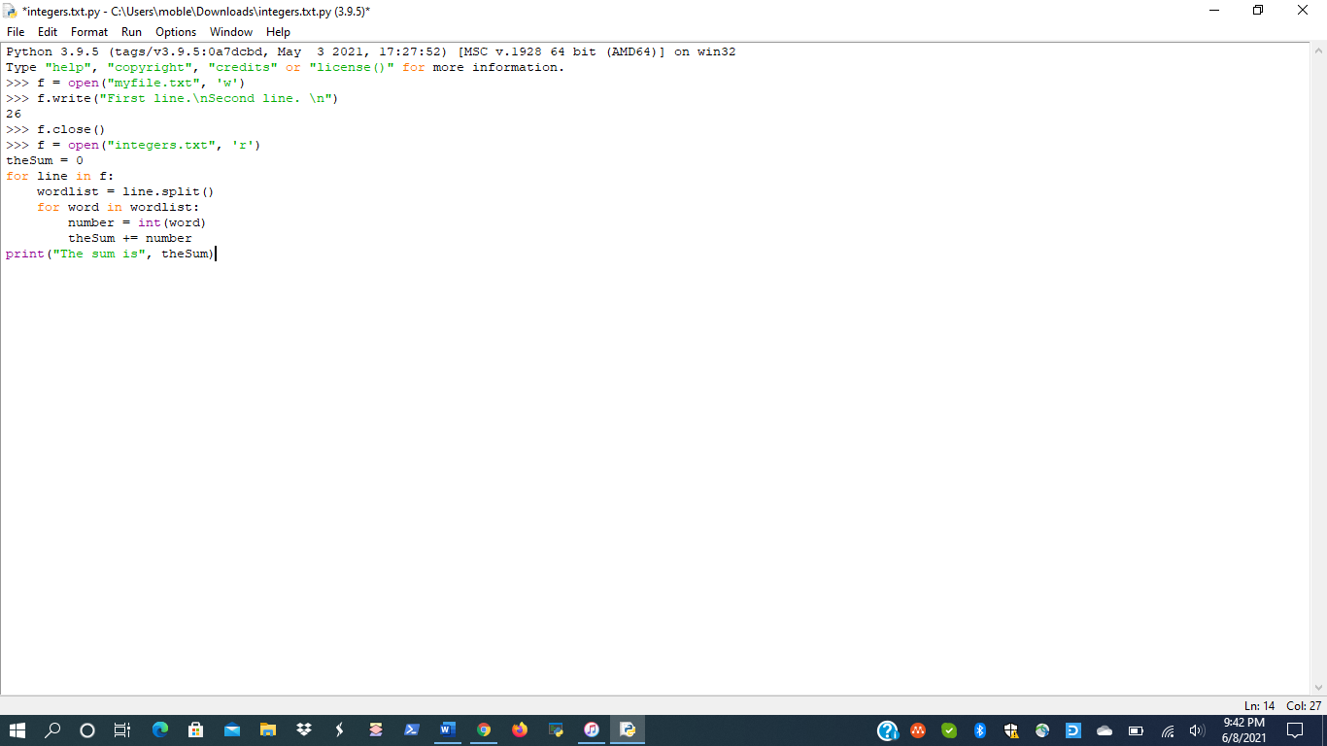

Pg. 123

No submission required.

Pg. 124

1.

